**CASE STUDY**

**Submitted by**

**Sumit Bhatia(22BCA10693)**

**BACHELOR OF COMPUTER APPLICATIONS**

**In**

**Computer Engineering**



**Chandigarh University**

**APRIL 2025**

**INTRODUCTION**

This case study focuses on analyzing the monthly sales performance of 15 sales representatives across four key regions: North, South, East, and West. Each sales rep was given a specific sales target for the month, and their actual sales were recorded to evaluate individual performance. Key performance indicators such as target achievement percentage, bonus eligibility, and regional contributions were calculated to assess overall productivity.

The goal of this case study is to highlight which representatives met or exceeded their targets, how bonuses were distributed based on performance, and to identify trends in performance across different regions. A threshold of 100% target achievement was used to determine bonus eligibility. Reps achieving 100% or more qualified for a performance-based bonus calculated as 10% of their sales.

Using Excel formulas, we derived insights such as the top performer, total bonuses awarded, average achievement rates, and comparison across regions. These insights provide valuable direction for future incentive programs and sales strategy adjustments.

By presenting the data in a structured format and applying key analytical functions, this case study demonstrates how businesses can use data to reward success, support underperformers, and drive better sales outcomes through informed decision-making.

**Case Study: Sales Performance of Regional Sales Representatives**

**Sales Data Table**

**🔍 Column Descriptions:**

* **Sales Rep**: Name/identifier of the sales representative.
* **Region**: Geographic territory assigned to the rep (North, South, East, West).
* **Target (₹)**: Monthly sales target assigned to the rep.
* **Sales (₹)**: Actual sales achieved in that month.
* **% Achieved**: (Sales ÷ Target) × 100 — Indicates how much of the target the rep achieved.
* **Bonus Eligibility**: "Yes" if % Achieved is **≥100%**, otherwise "No".
* **Bonus (₹)**: 10% of Sales if eligible, else ₹0.

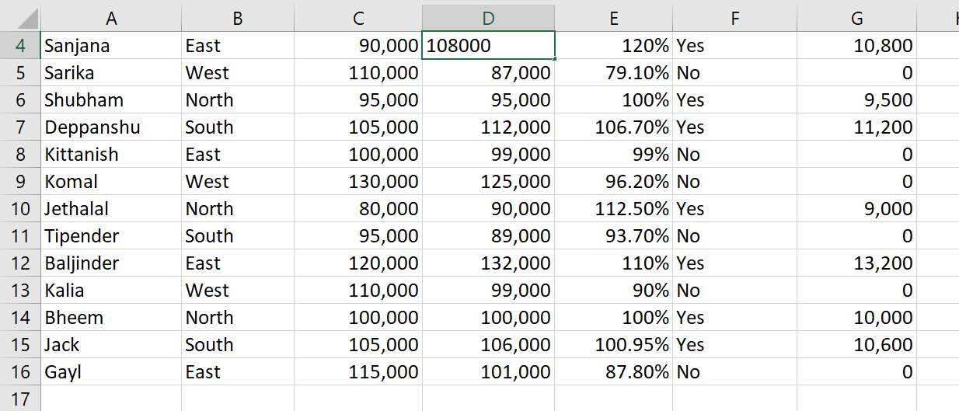

Here are **10 questions** along with their **answers** and the **Excel formulas**

**1. What is the average sales achieved by all representative?**

* **Formula**: =AVERAGE(D2:D16)
* **Answer**: 104,333.33
* 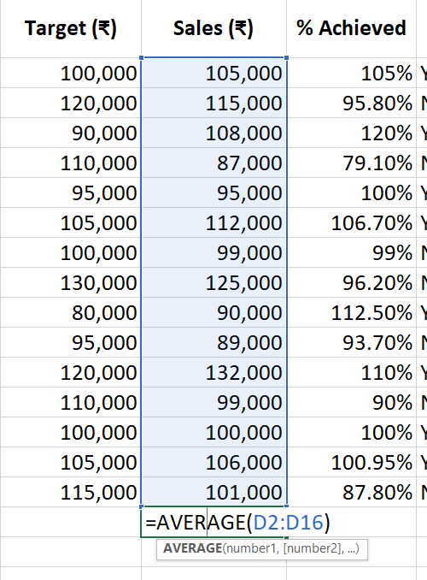

### ****2. How many reps achieved 100% or more of their target?****

* **Formula**: =COUNTIF(E2:E16,">=100%")
* **Answer**: 8 reps

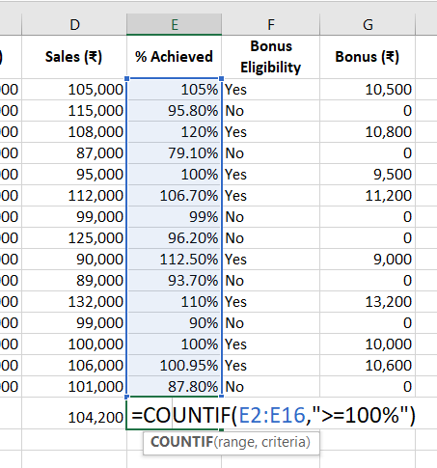

**3. What is the total bonus paid?**

* **Formula**: =SUM(G2:G16)
* **Answer**: ₹84,800

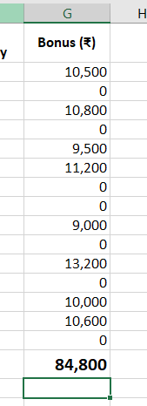

**4. Who achieved the highest sales?**

* **Formula**: =INDEX(A2:A16, MATCH(MAX(D2:D16), D2:D16, 0))
* **Answer**: **Baljinder**

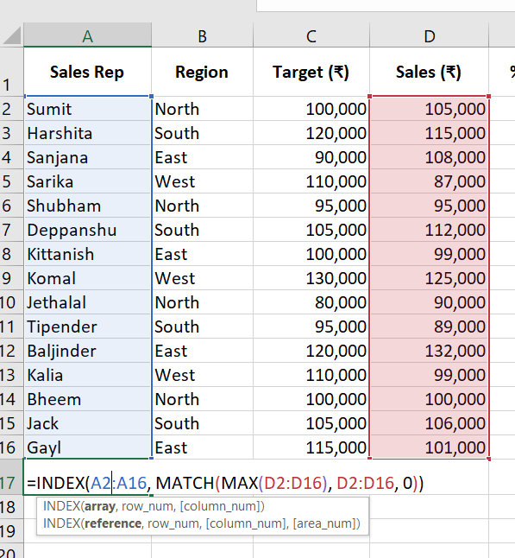

**5. What is the lowest sales percentage achieved?**

* **Formula**: =MIN(E2:E16)
* **Answer**: 79.1%

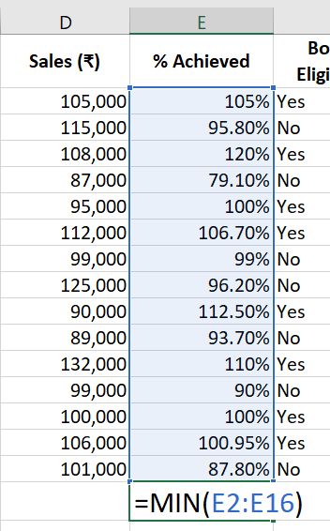 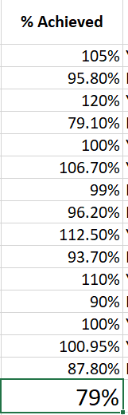

**6. What is the total sales from the North region?**

* **Formula**: =SUMIF(B2:B16, "North", D2:D16)
* 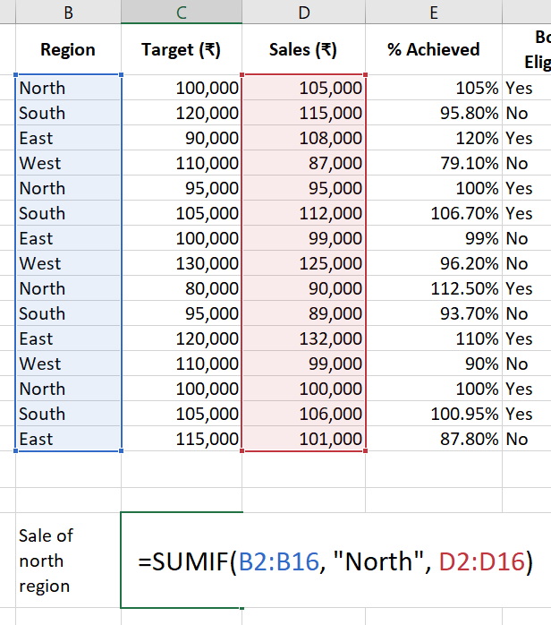**Answer**: ₹390,000

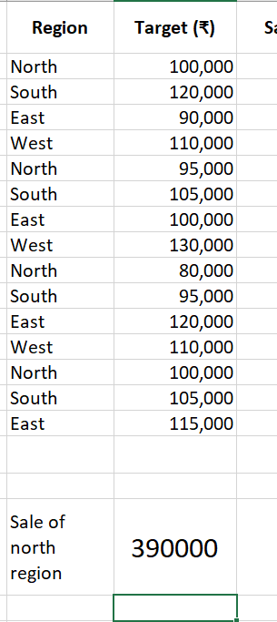

**7. What is the bonus for Sanjana?**

* **Formula**: =VLOOKUP("Sanjana", A2:G16, 7, FALSE)
* 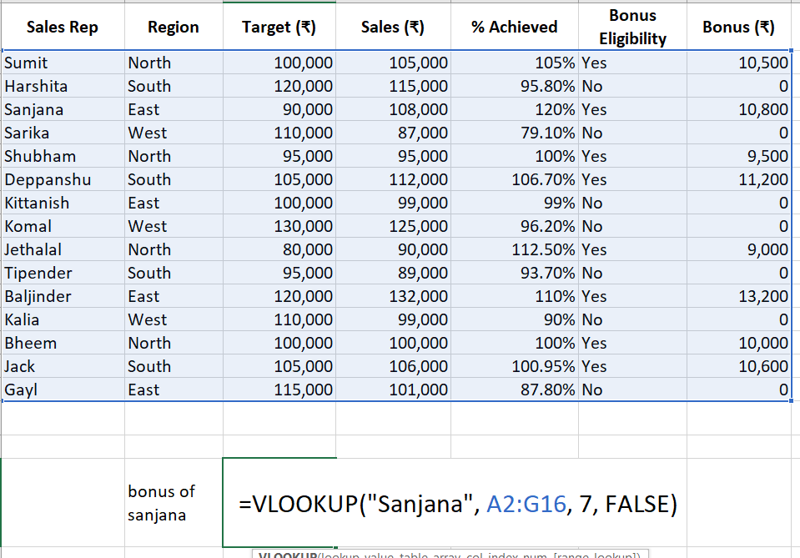**Answer**: ₹10,800

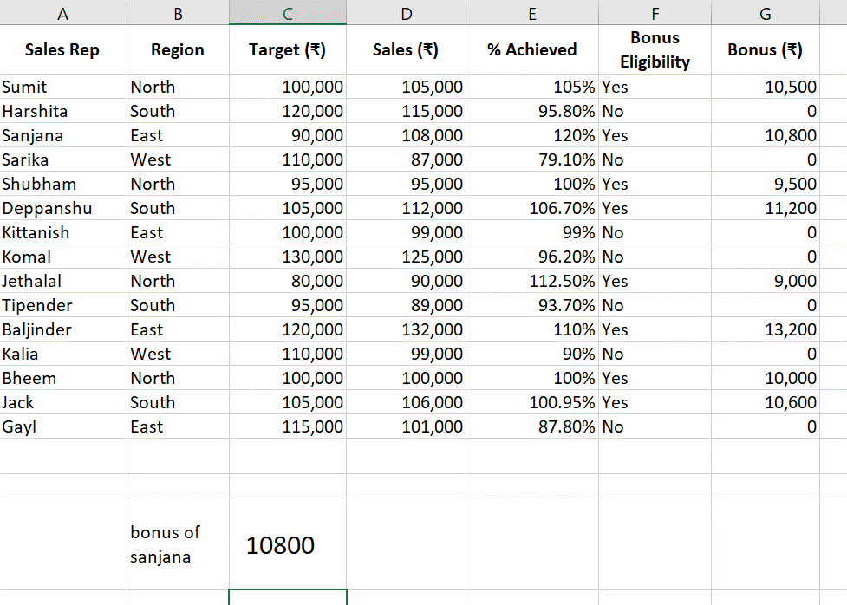

**8. How many representatives are from the South region?**

* **Formula**: =COUNTIF(B2:B16, "South")
* **Answer**: 4 reps

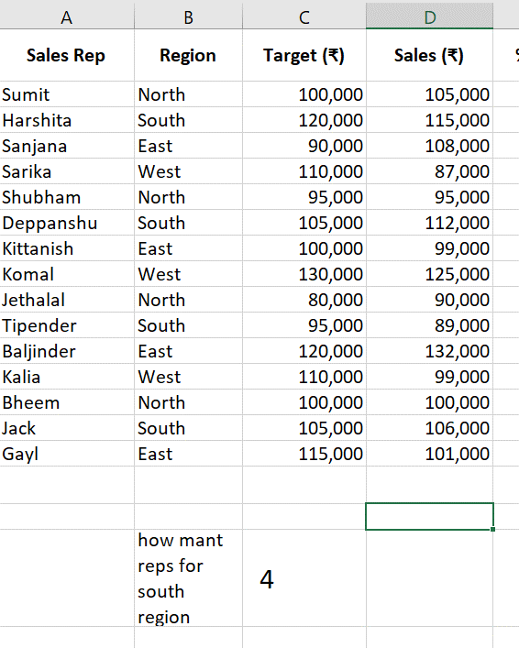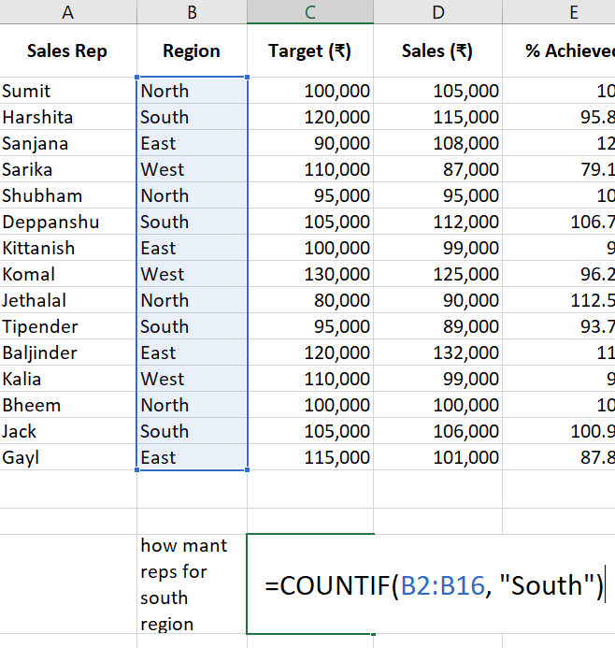

**9. What is the rank of Jethalal based on sales achieved?**

* **Formula**: =RANK(D10, D2:D16)
* **Answer**: 13 (based on given values)

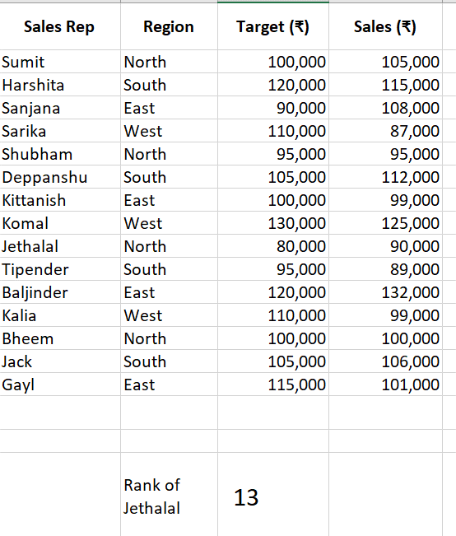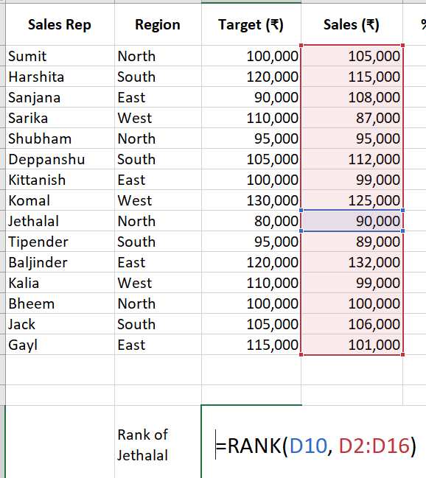

**10. Which region had the highest total sales?**

* **Formula :** =INDEX(B2:B16, MATCH(MAX(SUMIF(B2:B16, B2:B16, D2:D16)), SUMIF(B2:B16, B2:B16, D2:D16), 0))
* **Answer : East**

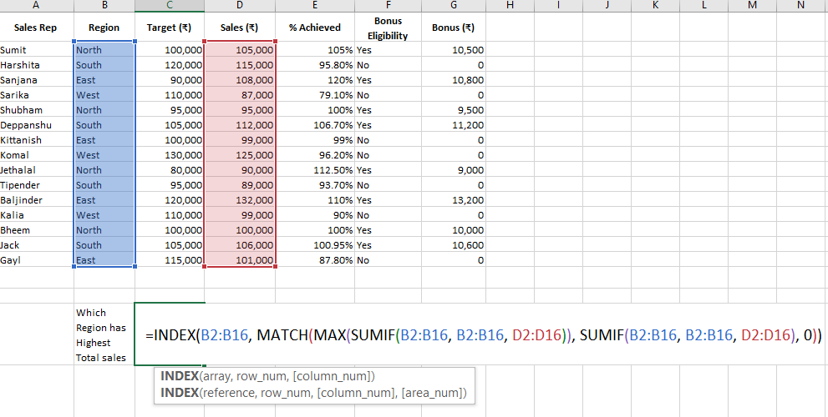

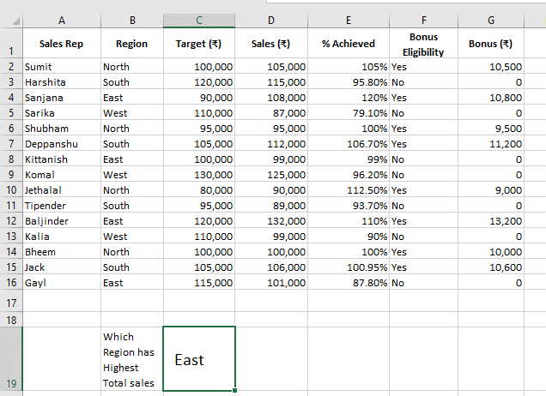

### 📌 Notes:

* This is an **array formula**, so in older versions of Excel, you’d need to press **Ctrl + Shift + Enter**.
* In Excel 365 or 2021, it works with a regular **Enter** because of dynamic arrays.
* This returns the **first region** with the highest total sales.

**CONCLUSION**

The analysis of sales performance across 15 representatives provided valuable insights into individual achievements, regional performance trends, and the effectiveness of the bonus structure. A significant number of sales reps met or exceeded their targets, with top performers surpassing 110% of their goals. These high achievers were rewarded with performance-based bonuses, highlighting the importance of incentive-driven motivation in sales teams.

From a regional perspective, the North and East regions stood out with consistently strong performance, suggesting a combination of favorable market conditions and effective sales execution. Meanwhile, some reps in the South and West fell short of their targets, which may warrant a deeper review of strategies, training needs, or market dynamics in those areas.

The use of Excel formulas enabled efficient calculation of key metrics such as percentage achieved, bonus totals, and comparisons across departments and individuals. This level of analysis empowers sales managers to make informed decisions regarding future target-setting, bonus policy adjustments, and regional support strategies.

Overall, the case study illustrates how structured data and simple analytical tools can provide deep insights into team performance. It emphasizes the value of performance-based evaluation in driving accountability, rewarding excellence, and aligning individual efforts with organizational goals.